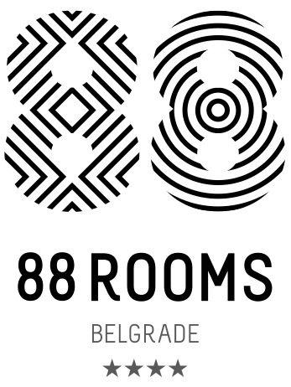
Reservation form for SKATE HELENA 15.-19.January 2019.
88 Rooms Hotel Belgrade
Guest Name:_____________________________________________________________________
Week days (Monday-Thursday) Weekend (Friday-Sunday)
Room type
Standard M room, single use € 80.00 €75.00
Standard double M room, double use € 82.00 € 82.00
Comfort triple L room, triple use € 123.00 € 123.00
Connected room for 4 persons € 164.00 € 164.00
Connected room for 5 persons € 190.00 € 190.00
Above mentioned rates are per room/per night.
Child policy: Children from 02-12y if share bed with one or two adults stay free of charge.Children from 12 years old full payment requires.
Room rate includes: Full buffet breakfast, Wi fi internet access available in the whole hotel(high speed internet), coffee and tea bags in the room, Fitness center usageRoom rate excludes insurance and citizen tax at the amount of €1.5 per person, per night. Children from 02-07years do not pay citizen taxes (only insurance 0.3 € per night). Children from 07-15 years pay 50% of the citizen tax amount.
Arrival date:____________________________________________________
Departure date: ________________________________________________
Credit card number (required)__________________________________________
Expiry date (required)___________________________________________________
Signiture(requred)_______________________________________________________
By signing this form I guarantee the above booking to this credit card and accept the terms of cancellation.
As a payment method guests can use following credit cards: VISA, MASTER , MAESTRO,AMEX,DINNERS CARD.
Credit card from reservation form can be used only for guarantee of reservation.Reservation can be cancelled free of charge until 20.12.2018.In case of late cancellation (after this deadline) or in case of no show and early departures, the guest will be charged for whole period of staying .Reservation form have to be send on the e-mails: reservations@88rooms.com or ivana.dapcevic@88rooms.comAll reservation request need to be confirmed by e-mail by hotel reservation department.
88 ROOMS Hotel, A: Takovska 49, 11 000 Beograd, Srbija, T: +381 11 411 9088, F: +381 11 411 9008E: reception@88rooms.com, www.88rooms.com
MK Aviation Services doo Beograd, A: BulevarMihajlaPupina 115e, 11 070 Novi Beograd, Srbija
Matičnibroj: 20778253, PIB 107306422, Tekući račun: 275-10222546744-90 Societe Generale banka Srbija AD Beograd

